The 2013 Lewisburg Christmas Bird Count

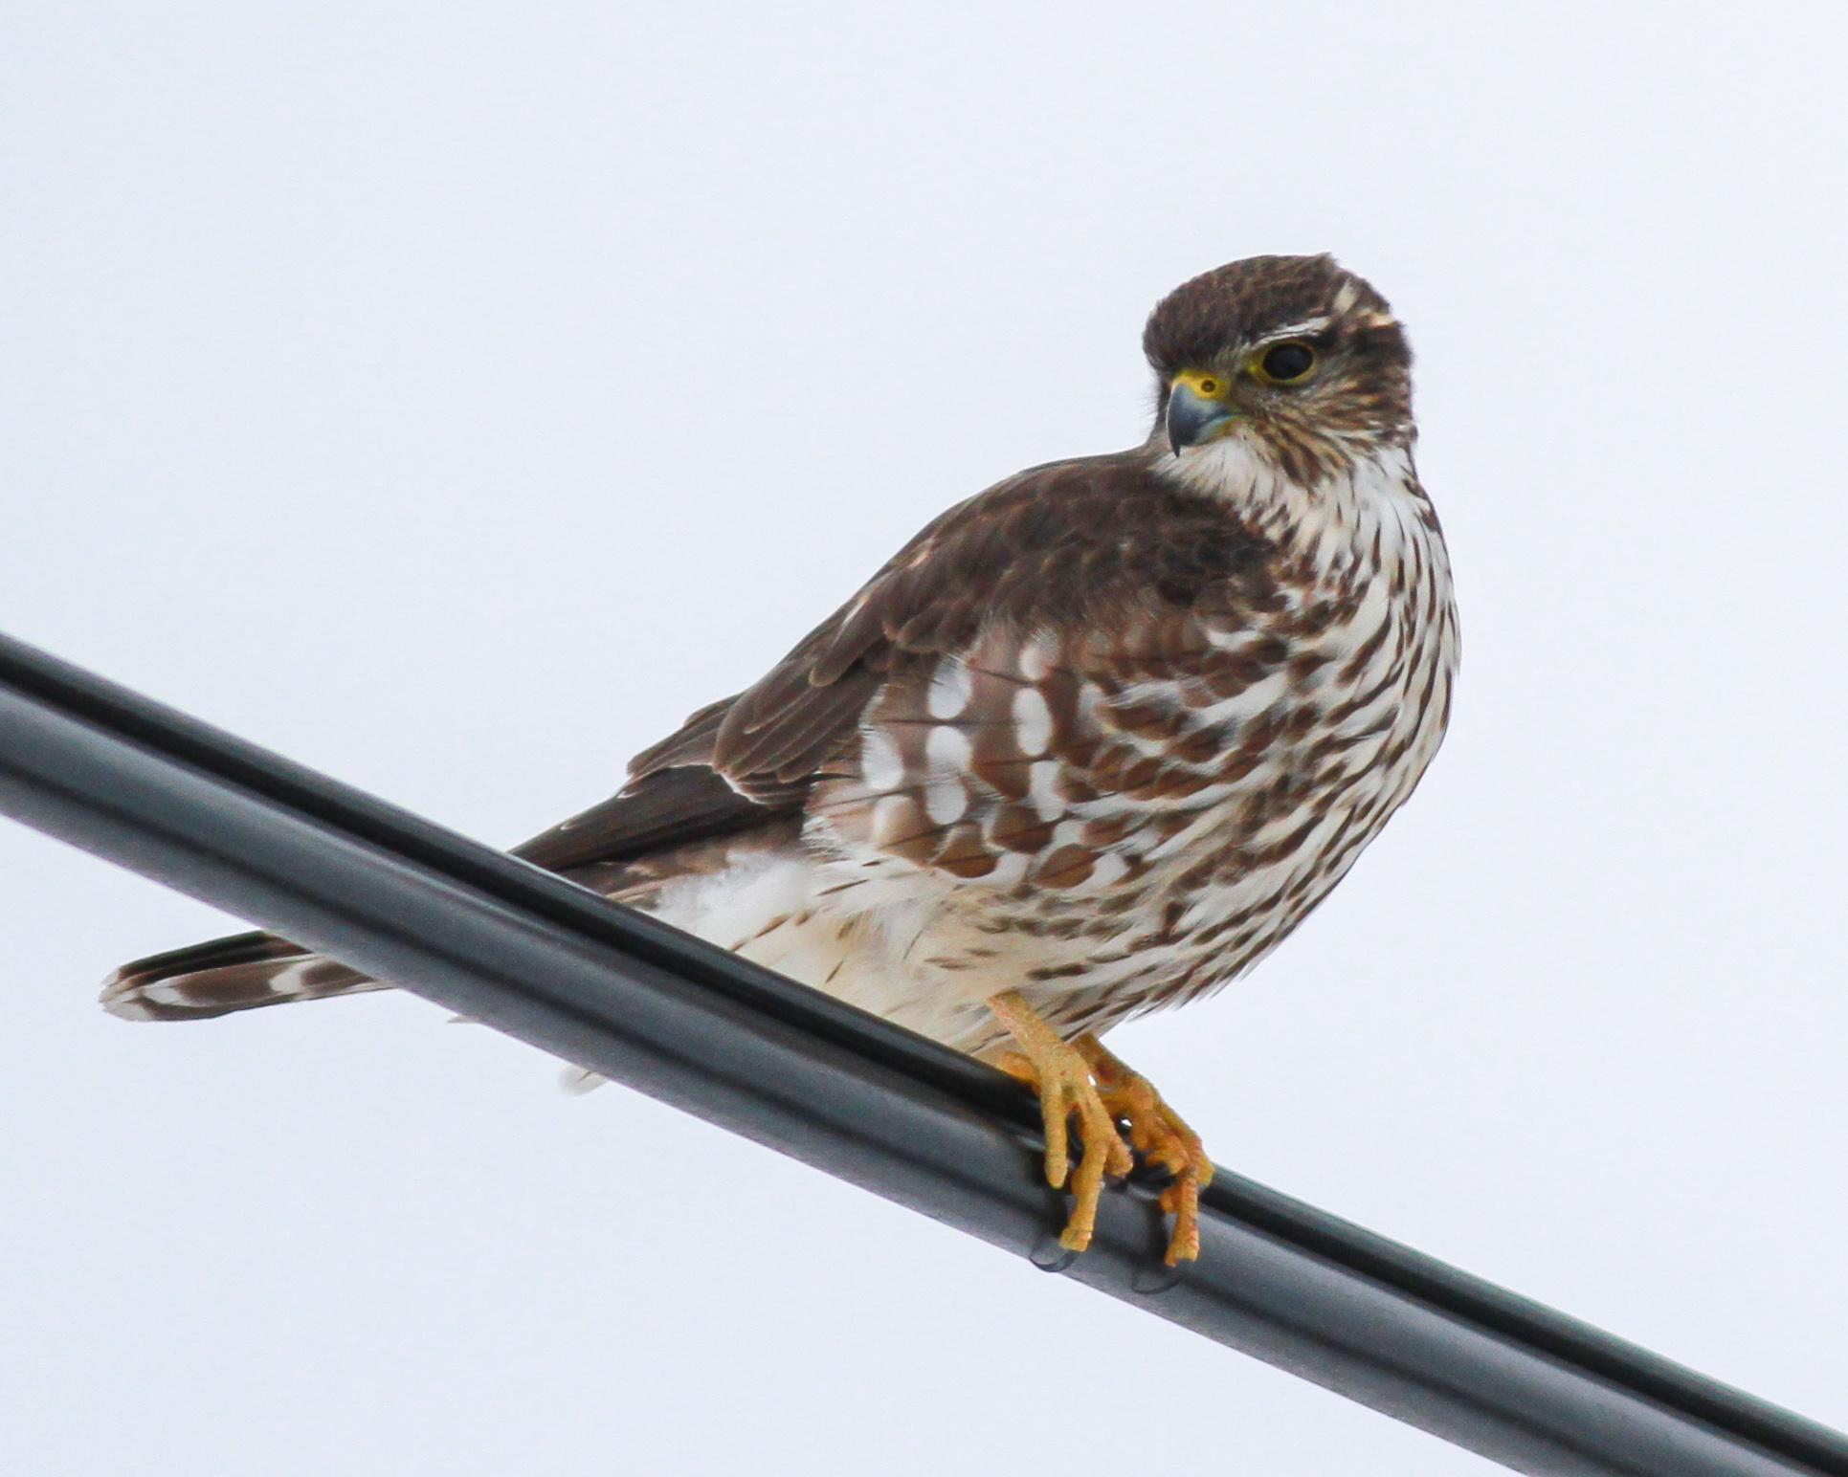
Merlin by Matt Levanowitz, photographed near Montandon during the count

This was a ******snowy****** year, as our count circle received 5 – 8 inches during the afternoon and evening prior to count day. In spite of uncertain roads, 44 brave participants got outdoors and produced a fine team effort. Most roads were in acceptable condition after early morning, but roadside parking was severely limited. Not all of us were able to walk in our favorite spots, yet several participants remarked that they enjoyed Christmas counting in conditions that were “different.”

The 68 reported species is higher than might be expected under the conditions, and we had a very nice collection of exceptional birds. It was the year of the Merlin, a species never found on our count prior to 2001. We had three – one seen by Matt Levanowitz, one by the Schweinsbergs, and one by Robert Hazard and Dianne Muchant.

And two catbirds! And four sapsuckers! Our first Snow Geese in twelve years. Both vultures, Fox Sparrow, Hermit Thrush, one pheasant, one robin. Perhaps the best bird of all was only heard, not seen. Nick Block enticed a Northern Saw-whet Owl to respond to a recording for his first bird of the day. This is only the 5th occurrence of a saw-whet in our 64-year history.

Surprisingly, we set or tied 13 high count records. These were for Snow Goose, Canada Goose, Bald Eagle, Sharp-shinned Hawk, Red-tailed Hawk (tie), Merlin, Herring Gull, Saw-whet Owl (tie), Red-bellied Woodpecker, Pileated Woodpecker, Gray Catbird (tie), Song Sparrow, and Dark-eyed Junco.

Fourteen eagles! – what a wonderful development. Certainly, some of these may have been duplicates. Large, high-flying birds can easily be seen by more than one party (geese is the obvious example), but, whatever the exact number, Bald Eagles continue to increase.

A Snow Bunting was reported on December 16 by Brent Bacon, allowing us to denote that species as a “count week” species.

Chickadee numbers were exceptionally low, as they were two years ago. Thirteen of our 68 species were reported by only one party. Birds that we missed entirely included Ruffed Grouse, Rough-legged Hawk, Fish Crow, Red-breasted Nuthatch, Cedar Waxwing, Field Sparrow, Swamp Sparrow, and Pine Siskin.

Our 45 participants included: Warren Abrahamson, Mark & Sarah Berryman, Nicholas Block, Steve Anderson, Caroline Campagna, Roy Fontaine, Warren Frantz, Kerry Givens, Geoff Goodenow, Allan & Ann Grundstrom, Bob Gutheinz, Robert Hazard, David Hafer, Rolf & Annick Helbig, John Holback, Galen & Bonnie Ingram, Jill Largent, Jim & Diane Lengle, Matt Levanowitz, Jack McCann, Wayne McDiffett, Larry McGraw, Bill Malone, Debby Meade, Than Mitchell, Mike Molesevich, Dianne Muchant, Judy Peeler, Robert Reyda, Thom Rippon, Allen & Joanne Schweinsberg, Carl Shaffer, Joe & Emily & Luke Southerton, Logan Stenger, Stephanie Thomas, Don Ulrich, Tom Yannaccone. Please come back next year!

It is very satisfying to be part of this considerable community of folks who share an enthusuasm for the Christmas Count tradition.

The results:

Snow Goose 200
Canada Goose 2121
Wood Duck 2
American Black Duck 7
Mallard 427
Bufflehead 2
Common Merganser 115
Ring-necked Pheasant 1
Wild Turkey 18
Great Blue Heron 15
Black Vulture 22
Turkey Vulture 1
Bald Eagle 14
Northern Harrier 9
Sharp-shinned Hawk 7
Cooper’s Hawk 11
Accipiter sp. 2
Red-shouldered Hawk 2
Red-tailed Hawk 123
American Kestrel 61
Merlin 3
Killdeer 6
Wilson's Snipe 13
Ring-billed Gull 61
Herring Gull 60
Rock Pigeon 1079
Mourning Dove 1520
Barn Owl 3
Screech Owl 5
Great Horned Owl 5
Snowy Owl (1 count week)
Barred Owl 1
Saw-whet Owl 1
Belted Kingfisher 11
Red-bellied Woodpecker 78
Yellow-bellied Sapsucker 4
Downy Woodpecker 100
Hairy Woodpecker 9
Northern Flicker 6
Pileated Woodpecker 19
Blue Jay 229
American Crow 612
Common Raven 13
Horned Lark 935
Black-capped Chickadee 118
Tufted Titmouse 200
White-breasted Nuthatch 78
Brown Creeper 7
Carolina Wren 80
Winter Wren 2
Golden-crowned Kinglet 20
Eastern Bluebird 117
Hermit Thrush 2
American Robin 1
Gray Catbird 2
Northern Mockingbird 37
European Starling 2531
American Tree Sparrow 87
Fox Sparrow 1
Song Sparrow 167
White-throated Sparrow 266
White-crowned Sparrow 19
Dark-eyed Junco 1214
Snow Bunting (1 count week)
Northern Cardinal 315
Common Grackle 70
Brown-headed Cowbird 1
Purple Finch 10
House Finch 116
American Goldfinch 65
House Sparrow 538

