The 2014
Dick Nickelsen
Christmas Bird Count

This, the 64st Lewisburg Christmas Bird Count, is dedicated to the memory of Dick Nickelsen. Dick, or “Nick” was a beloved figure in our birding community. All of us can agree with Dave Vernon’s tribute, “He added to my life in some wonderful ways.”
A past president of Seven Mountains Audubon, Dick was the compiler of this bird count for approximately twenty years. Christmas counts will not be the same without Dick’s annual query, “Where were all the sparrows?”

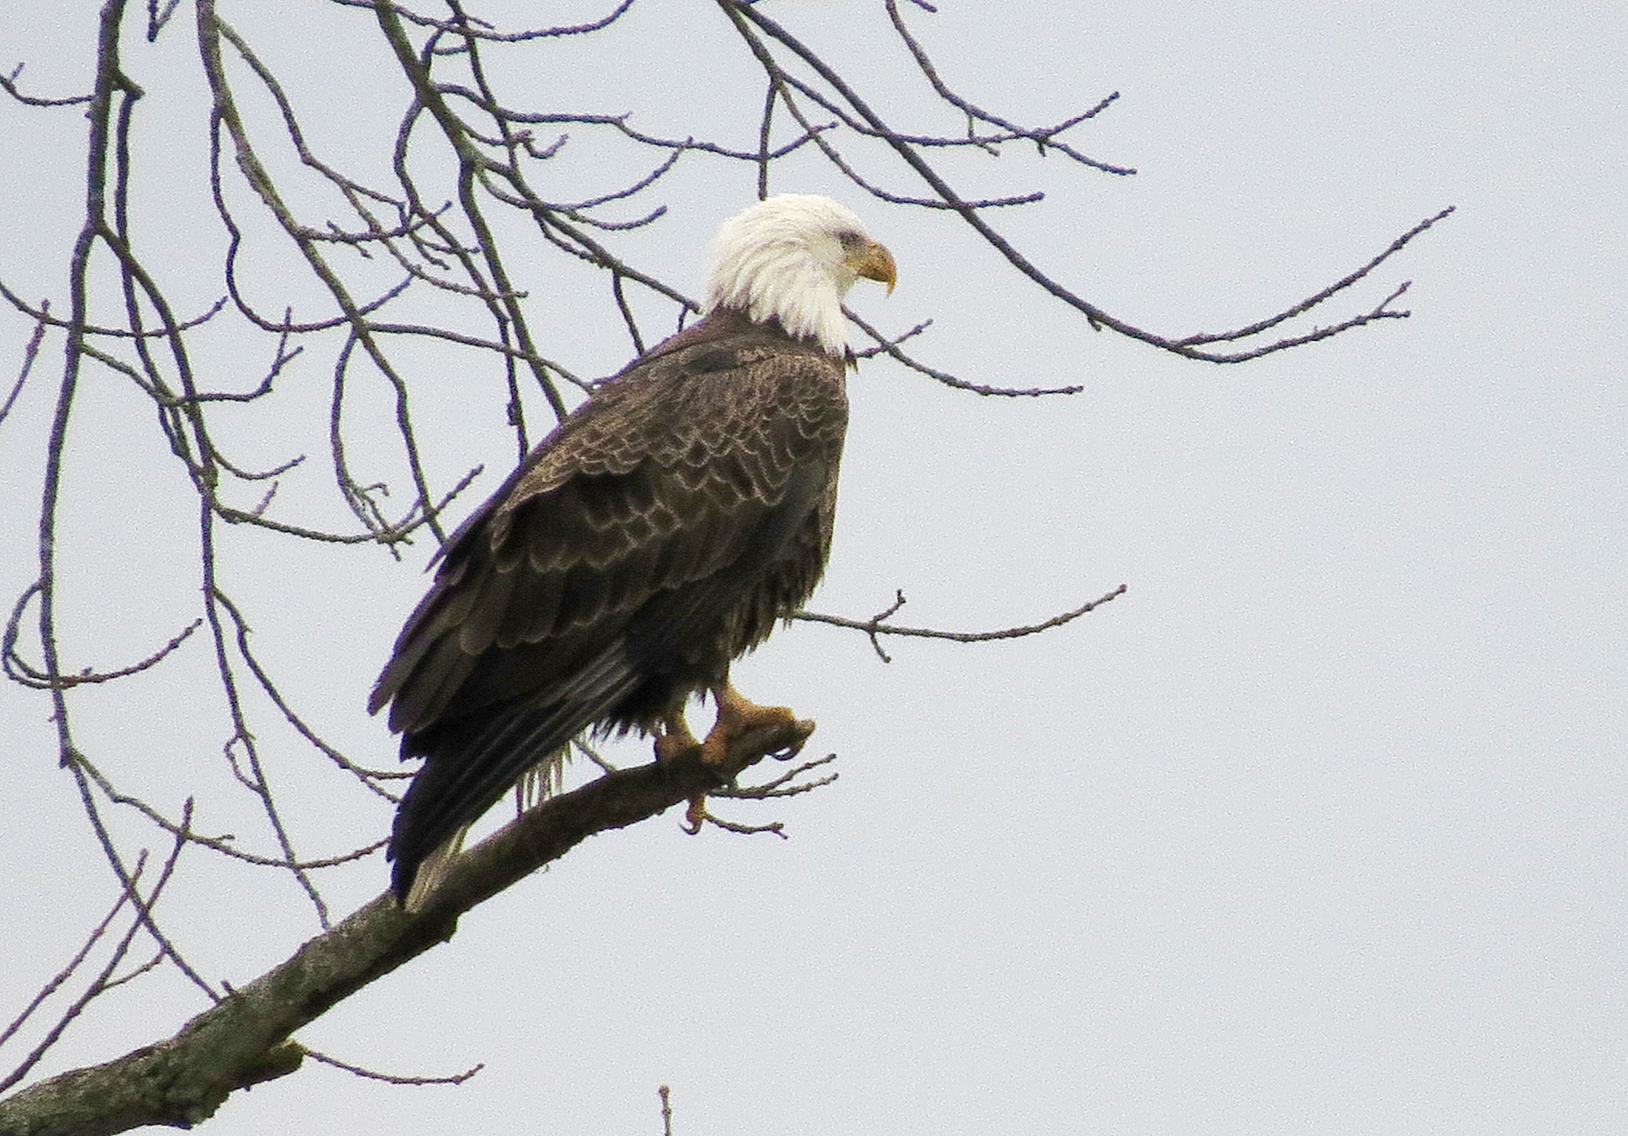
Bald Eagle by Kerry Givens, photographed during the count. Seven groups, scattered across the count circle, reported this species.

Not a red-letter year

Our species total, 61, was the lowest since 1973, the last count before Seven Mountains Audubon was formed. Birds that we found last year, but not this year included Snow Goose, Bufflehead, Ring-necked Pheasant, Wild Turkey, Turkey Vulture, Merlin, Killdeer, Herrinng Gull, Barn Owl, Barred Owl. Saw-whet Owl, Winter Wren, Gray Catbird, Common Grackle, and Brown-headed Cowbird. Among these, Wild Turkey had not been missed in the past 16 years. Our Red-tailed Hawk total was the lowest in many years, and American Kestrels were noticibly few as well.

Still, we had bright moments. Ruffed Grouse, Pied-billed Grebe, Red-breasted Nuthatch, Ruby-crowned Kinglet, Cedar Waxwing, Yellow-rumped Warbler, Field Sparrow, and Swamp Sparrow were birds that appeared this year, but not in 2013. The Pied-billed Grebe was only the third in 22 years. The Yellow-rumped Warbler was the first in 15 years. Downy and Hairy Woodpeckers were conspicuously common, and the White-breasted Nuthatch tally was the best in 15 years.

Black Vultures continue to congregate in the vicinity of T&D’s Cats of the World near Penns Creek. This year Jen Mattive counted 61, an impressive number for a species that is difficult to find in our region.

It’s hard to imagine the excitement in 1971 when two Red-bellied Woodpeckers were found on the Lewisburg count for the first time. By last year we had reached a high of 78, but we even topped that with 86 this year. This was our only high-count record for 2014.

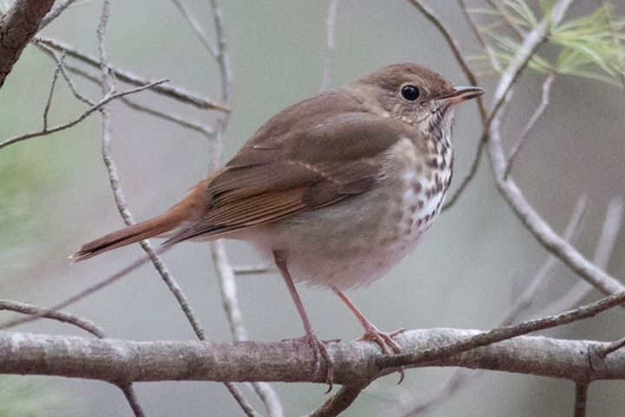
Hermit Thrush by David Brown, photographed during the count. Four were found on Sunday, one of which came in to investigate a Screech Owl recording.

Two parties!

We had, not one, but two festive parties after the count. Our kitchen and living room quickly filled with early arrivals, all of whom slipped out by 5:45pm, exhausted no doubt by the day’s efforts. Immediately thereupon a second shift of revelers arrived to spread cheer and feast on bird conversation late into the night (about 6:45pm). Too bad the groups missed each other, but Joanne and I enjoyed one and all.

Our 53 participants included: Warren Abrahamson, Brent & Su Bacon, Mark & Sarah Berryman, Pat Bontinen, David Brown, JoAnn Cooper, Ken Eisenstein, Judy Ellis, Betsy Fickes, Roy Fontaine, Kerry Givens, Geoff Goodenow, Roma Greenly, Bob Gutheinz, Robert Hazard, David Hafer, Lucy Heggenstaller, John Holback, Galen & Bonnie Ingram, Janet Jones, Jill Largent, Jim & Diane Lengle, Jack McCann, Wayne McDiffett, Larry McGraw, Bill Malone, Jen Mattive, Debby Meade, Rebecca Meyers, Than & Margaret Mitchell, Mike Molesevich, Dianne Muchant, Judy Peeler, Robert Reyda, Thom Rippon, Allen & Joanne Schweinsberg, Bill & Ellen Snyder, Joe & Emily & Luke Southerton, Steve Stanko, Logan Stenger, Lynn Tanner, Don Ulrich, Norma Gay Wands, Tom Yannaccone.

Please save Saturday, December 19, for the 2015 Christmas Bird Count
The results:

Canada Goose 835
Wood Duck 1
American Black Duck 3
Mallard 254
Common Merganser 39 Ruffed Grouse 8
Pied-billed Grebe 1
Great Blue Heron 14
Black Vulture 61
Bald Eagle 10
Northern Harrier 1
Sharp-shinned Hawk 4
Cooper’s Hawk 9
Accipiter sp. 2
Red-shouldered Hawk 1
Red-tailed Hawk 64
Wilson's Snipe 2
Ring-billed Gull 2
Rock Pigeon 586
Mourning Dove 230
Screech Owl 9
Great Horned Owl 5
Belted Kingfisher 11
Red-bellied Woodpecker 86 Yellow-bellied Sapsucker 1
Downy Woodpecker 122
Hairy Woodpecker 19
Northern Flicker 16
Pileated Woodpecker 14 American Kestrel 30
Blue Jay 194
American Crow 626
Common Raven 3
Horned Lark 42
Black-capped Chickadee 241
Tufted Titmouse 158
Red-breasted Nuthatch 4
Wte-breasted Nuthatch 133
Brown Creeper 6
Golden-crowned Kinglet 8 Carolina Wren 66
Ruby-crowned Kinglet 1 Eastern Bluebird 115
Hermit Thrush 4
American Robin 12
Northern Mockingbird 42
European Starling 3465
Cedar Waxwing 24
Yellow-rumped Warbler 1
American Tree Sparrow 35
Field Sparrow 7
Fox Sparrow 1
Song Sparrow 69
Swamp Sparrow 1
White-throated Sparrow 293
White-crowned Sparrow 17
Dark-eyed Junco 390
Northern Cardinal 160
Purple Finch 11
House Finch 182
American Goldfinch 115
House Sparrow 346

