The 2015
Lewisburg
Christmas Bird Count

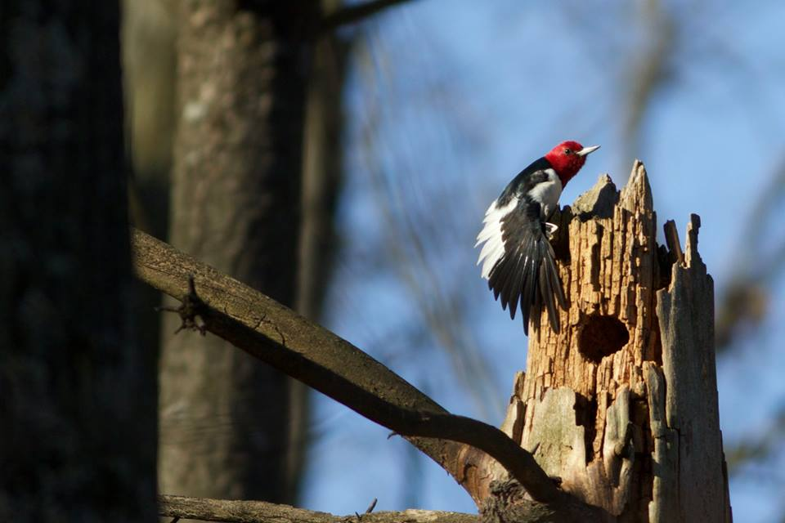

This Red-headed Woodpecker, discovered by Bill & Ellen Snyder, has been frequenting the same dead snag along Wolfeland Road for days. Tipped off by Bill & Ellen, Allen & Joanne Schweinsberg found it on count day right where it was supposed to be. Photo by Bill Snyder.

An all-time first

That would be a Golden Eagle, never found previously on the Lewisburg count, which began in 1949. Thom Rippon and Lucy Heggenstaller spotted it overhead at Thom’s farm on Saturday afternoon. Their description – a huge raptor with white areas in the central wings and at the base of the tail – is characteristic of a young Golden Eagle.

Another encounter of note was the river otter that Steve Anderson observed on the Susquehanna. That was consolation for a relatively barren waterfowl day that held down our species total.

We had 64 species, slightly up from last year’s low total. Given the sudden cold weather, plus fifteen mph winds, conditions were below par for birding. Most folks experienced an exceptionally quiet afternoon.

Evidence that last winter was fairly harsh appeared in the Carolina Wren totals – 17, way down from 66 the previous year. Other species with relatively low numbers included Great Blue Heron, Blue Jay, Song Sparrow, and White-throated Sparrow.

A comparison with 2014 shows that Hooded Merganser, Ring-necked Pheasant, Wild Turkey, Rough-legged Hawk, Golden Eagle, Killdeer, Herring Gull, Red-headed Woodpecker, Winter Wren, Savannah Sparrow, and Pine Siskin were birds that appeared this year, but not last. The Rough-legged Hawks were the first since 2010, and the Pine Siskin was the first since 2008.

Birds that we found last year, but not this year included Ruffed Grouse, Pied-billed Grebe, Red-shouldered Hawk, Red-breasted Nuthatch, Hermit Thrush, Yellow-rumped Warbler, Fox Sparrow, and Purple Finch.

Black Vultures continue to winter in the vicinity of T&D’s Cats of the World near Penns Creek. This year Jen Mattive counted 81, an impressive number for a species that is difficult to find in our region. That was our only all-time high total this year (other than 1 Golden Eagle, of course).

Now, about those Screech Owls. Allen and Joanne Schweinsberg located eight between 6 am and 7:15. The total number of Screech Owls for all parites combined was – eight. Come on folks, they respond readily to a recording.

Party!

Once again, Joanne and I enjoyed hosting a weary gang of birders early Saturday evening. We heard tales – three eagles in one tree! – a mystery photograph that no one could identify – a lone pheasant sighting! Plus hot cider and snacks. If only all 42 participants could have attended.

The 42 birders included: Warren Abrahamson, Steve Anderson, Sarah Berryman, Kay Cramer, Betsy Fickes, Roy Fontaine, Kerry Givens, Geoff Goodenow, Roma Greenly, Ann Grundstrom, Bob Gutheinz, David Hafer, Lucy Heggenstaller, Rolf & Annick Helbig, Galen & Bonnie Ingram, Jill Largent, Jim & Diane Lengle, Bill Malone, Barbara Martin, Jen Mattive, Jack McCann, Wayne McDiffett, Larry McGraw, Michael McGuire, Debby Meade, Mike Molesevich, Judy Peeler, Robert Reyda, Thom Rippon, Allen & Joanne Schweinsberg, Bill & Ellen Snyder, Joe & Lukas Southerton, Logan Stenger, Lynn Tanner, Don Ulrich, Tom Yannaccone.

Please save Saturday, December 17, for the 2016 Christmas Bird Count

The results:

Canada Goose 638
Wood Duck 2
American Black Duck 2
Mallard 300
Hooded Merganser 3
Common Merganser 34
Ring-necked Pheasant 1
Wild Turkey 37
Great Blue Heron 4
Black Vulture 81
Bald Eagle 13
Northern Harrier 6
Sharp-shinned Hawk 3
Cooper’s Hawk 5
Accipiter sp. 1
Red-tailed Hawk 75
Rough-legged Hawk 2
Golden Eagle 1
Killdeer 1
Wilson's Snipe 3
Ring-billed Gull 247
Herring Gull 1
Rock Pigeon 820
Mourning Dove 156
Screech Owl 8
Great Horned Owl 3
Belted Kingfisher 10
Red-headed Woodpecker 1
Red-bellied Woodpecker 72 Yellow-bellied Sapsucker 1
Downy Woodpecker 104
Hairy Woodpecker 15
Northern Flicker 18
Pileated Woodpecker 11 American Kestrel 33
Blue Jay 86
American Crow 777
Common Raven 16
Horned Lark 161
Black-capped Chickadee 113
Tufted Titmouse 124
Wte-breasted Nuthatch 136
Brown Creeper 5
Golden-crowned Kinglet 11
Ruby-crowned Kinglet 2
Carolina Wren 17
Winter Wren 1
Eastern Bluebird 223
American Robin 22
Northern Mockingbird 30
European Starling 2985
Cedar Waxwing 28
American Tree Sparrow 86
Field Sparrow 17
Savannah Sparrow 2
Song Sparrow 37
Swamp Sparrow 1
White-throated Sparrow 100
White-crowned Sparrow 14
Dark-eyed Junco 598
Northern Cardinal 123
House Finch 109
Pine Siskin 1
American Goldfinch 125
House Sparrow 402

