The 2018
Lewisburg
Christmas Bird Count

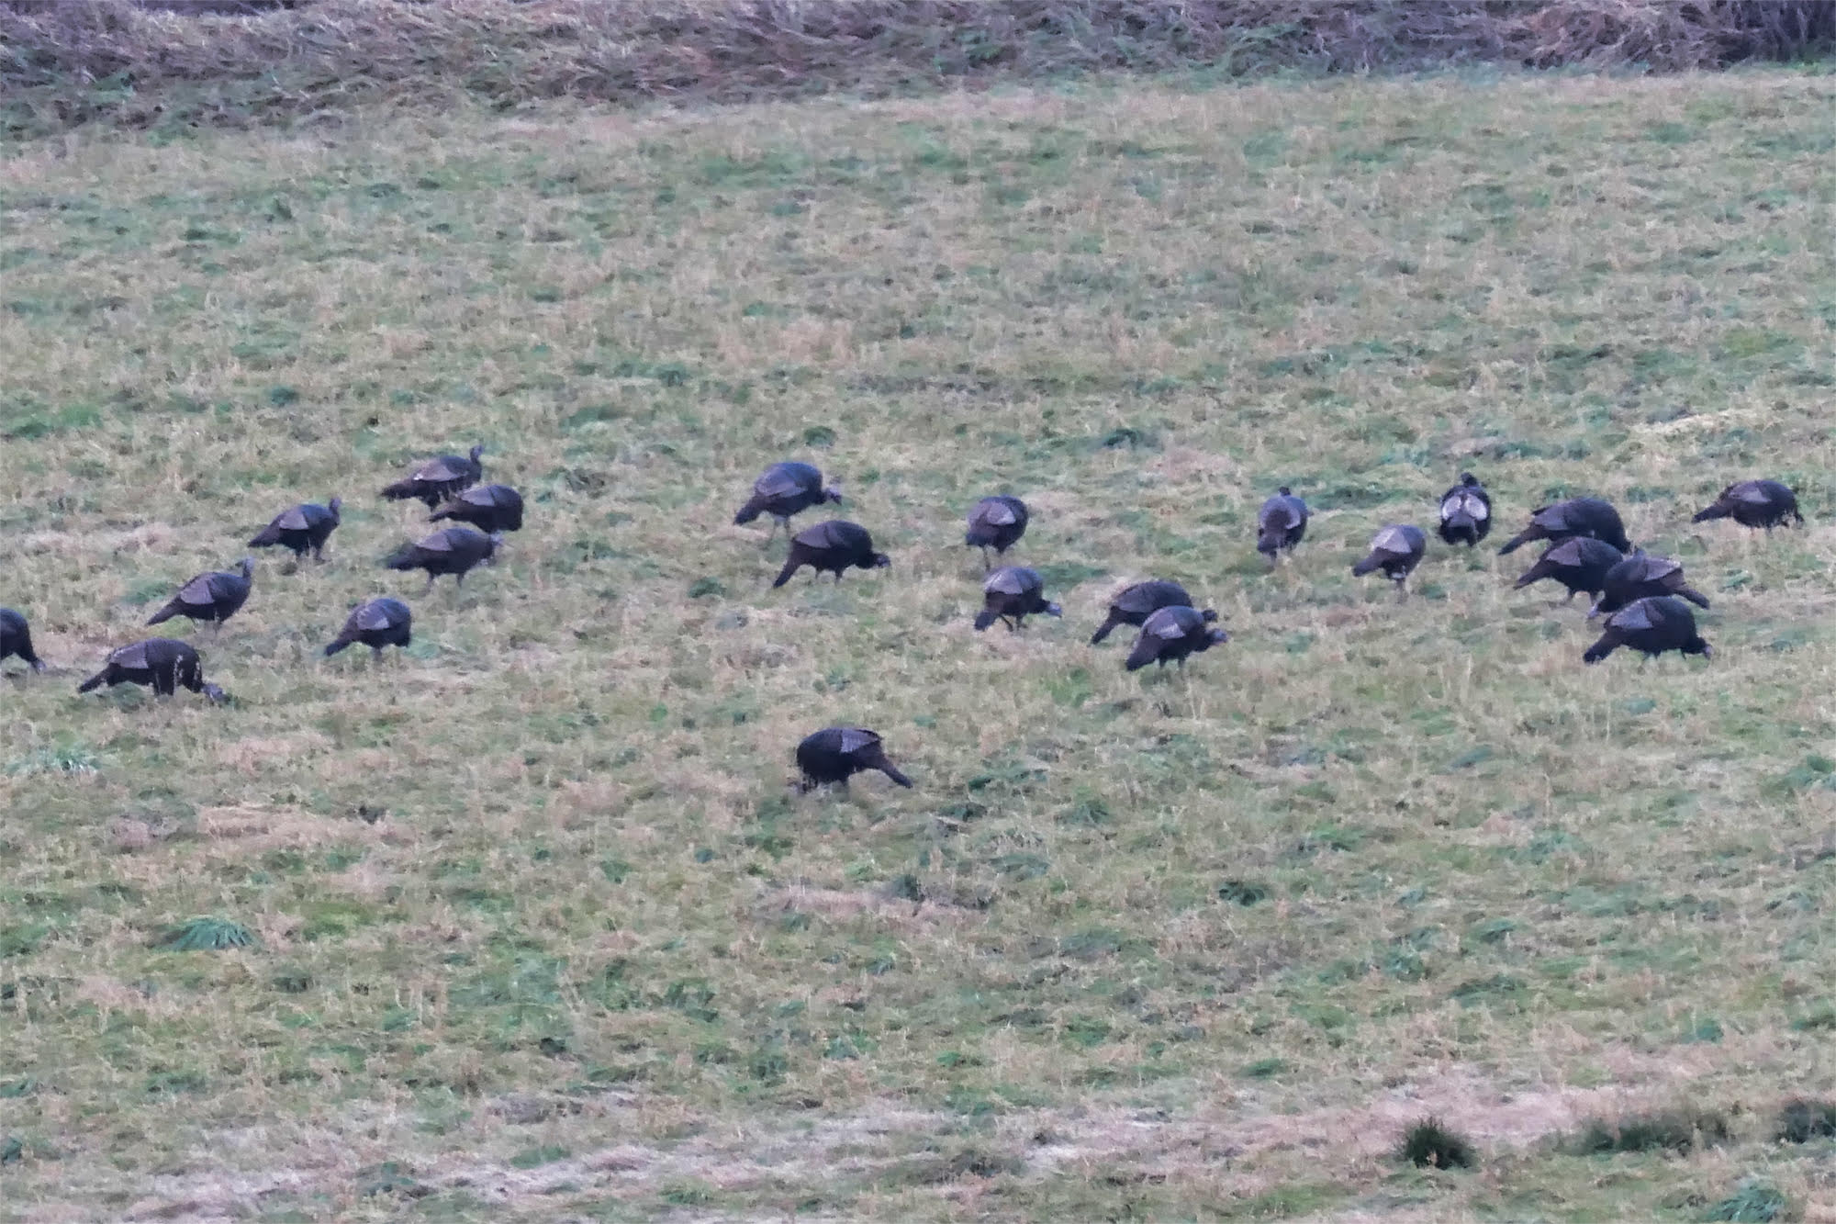

-- count day photo by Kerry Givens

Notables

It was the year of the Carolina Wren. Our tally of 92 exceeded that of any previous count. This species sings all year, making them easy to detect, and this year they seemed to be everywhere.
Wild Turkey, now much more common than in past years, are still easy to miss, which we did last year. Nevertheless, in 2018 we were fortunte to have the second highest count in our 70-year history (see photo).
We had one Long-eared Owl, our first in 25 years.
No Horned Lark; the last time we failed to get a Horned Lark was 1973.
No Wilson’s Snipe, our second miss in 30 years.
We had very low numbers for junco and titmouse.

In last year’s report we noted that the American Crow tally was the lowest ever for the Lewisburg Christmas Count, lower even than in 1949 when count founder Hollis Ross was the only observer. The collapse continues. Our 118 crows were fewer than half of last year’s 264. As recently as 1999 we estimated 30,000 crows, which was only a portion of the winter roost that then occupied Milton Island.

We had 59 species altogether, down four from last year, now our lowest species total since 1971. We had the expected common birds, but struggled to get much else. A comparison with 2017, also a down year, shows that Wood Duck, Bufflehead, Wild Turkey, Herring Gull, Long-eared Owl, and Cedar Waxwing were birds that appeared this year, but not last.
Birds that we found last year, but not this year, included Green-winged Teal, Black Vulture, Turkey Vulture, Rough-legged Hawk, Wilson’s Snipe, Horned Lark, Hermit Thrush, Swamp Sparrow, Lapland Longspur, and Purple Finch.

Our 31.5 observers included: Warren Abrahamson, Steve Anderson, Brent Bacon, Dutch the Dog, Betsy Fickes, Roy Fontaine, Kerry Givens, Bob Gutheinz, David Hafer, John Holback, Galen & Bonnie Ingram, Kevin & Johanna Klinger, Jill Largent, Jim & Diane Lengle, Bill Malone, Barbara Martin, Jen Mattive, Jack McCann, Wayne McDiffett, Mike Molesevich, Allen & Joanne Schweinsberg, Lauri Shaffer, Bill & Ellen Snyder, Emily Southerton, Joe Southerton, Steve Stanko, Logan Stenger, Bill Tyler, Don Ulrich, Tom Yannaccone.

Please save Saturday, December 14, for the 2019 Christmas Bird Count

The results:

Canada Goose 1070
Wood Duck 4

American Black Duck 9
Mallard 442
Bufflehead 3
Common Merganser 108
Ring-necked Pheasant 1
Ruffed Grouse 4
Wild Turkey 85
Great Blue Heron 12
Bald Eagle 11
Northern Harrier 3
Sharp-shinned Hawk 1
Cooper’s Hawk 6
Accipiter sp. 1
Red-tailed Hawk 58

Ring-billed Gull 39
Herring Gull 1
Rock Pigeon 575
Mourning Dove 229
Screech Owl 14
Great Horned Owl 6
Long-eared Owl 1
Belted Kingfisher 13
Red-headed Woodpecker 3
Red-bellied Woodpecker 69 Yellow-bellied Sapsucker 3
Downy Woodpecker 81
Hairy Woodpecker 16
Northern Flicker 24
Pileated Woodpecker 11
American Kestrel 21
Blue Jay 145
American Crow 118
Common Raven 11
Bl-capped Chickadee 147
Tufted Titmouse 53
Red-breasted Nuthatch 8
Wte-breasted Nuthatch 100
Brown Creeper 13
Golden-crowned Kinglet 13
Carolina Wren 92
Winter Wren 1
Eastern Bluebird 123
American Robin 21
Northern Mockingbird 26
European Starling 3855
Cedar Waxwing 42
American Tree Sparrow 21
Field Sparrow 13
Savannah Sparrow 1
Song Sparrow 56
White-throated Sparrow 369
White-crowned Sparrow 18
Dark-eyed Junco 264
Northern Cardinal 113
Brown-headed Cowbird 1
House Finch 101
American Goldfinch 72
House Sparrow 174

