The 2012 Lewisburg Christmas Bird Count

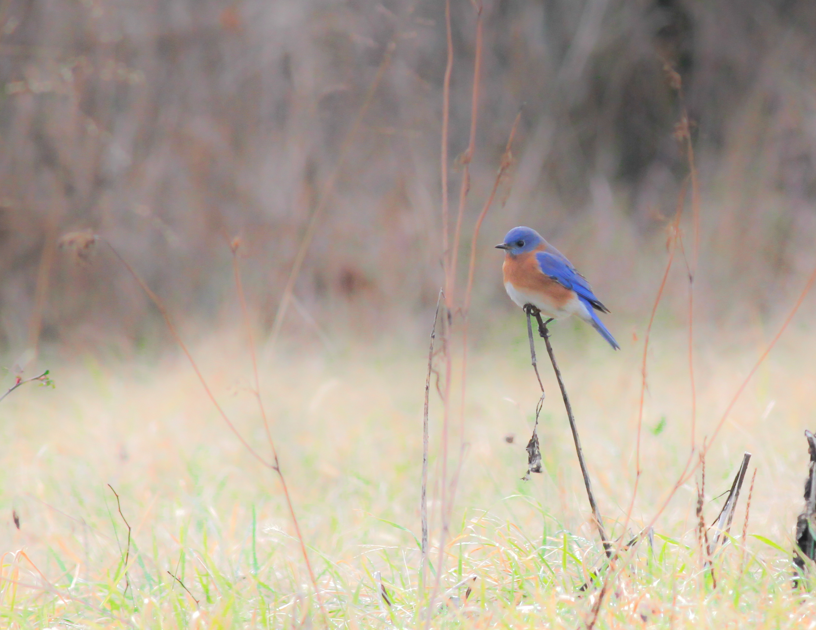
Eastern Bluebird by Matt Levanowitz, photographed on Dale’s Ridge during the count

I suppose one should expect about half of our Christmas Bird Counts to be “below average.” Well, this year we achieved that – in spades! Our total of 64 species was the lowest since 1980 and the 2nd lowest during the “modern era,” which began when Seven Mountains Audubon was formed.

On a much brighter note, I am confident we set a record for the number of participants (records are a little fuzzy on this). There were 51 wonderful friends and outdoor enthusiasts enjoying the event on Saturday. It’s satisfying to know so many folks who share an appreciation for wildlife and this annual tradition.

With no shortage of participants, we did manage to set a few high count records. There were 21 Belted Kingfishers reported, besting the old mark of 20. Sixty-two Red-bellied Woodpeckers was six higher than the prior record. And 86 Carolina Wrens thoroughly shattered the previous record of 65. This species thrives when we have a sequence of mild winters only to decline again after harsh seasons.

Nice finds included Bufflehead, Hooded Merganser, Ring-necked Pheasant (yes, that has become a “rare” bird), Bald Eagle (even though we now expect them), Barn Owl, Red-headed Woodpecker, Red-breasted Nuthatch, Winter Wren, Field Sparrow, Savannah Sparrow, Red-winged Blackbird, and Common Grackle. The four bold-faced species were absent from last year’s count.

A Red-shouldered Hawk was reported on December 13, allowing us to denote that species as a “count week” species.

There were just three Horned Larks! How was that possible? Birds that we missed entirely included Ruffed Grouse, Rough-legged Hawk, Yellow-bellied Sapsucker, Fish Crow, Hermit Thrush, Brown-headed Cowbird, and Pine Siskin.

Our 51 counters included: Warren Abrahamson, Roger Allison, Owen Anderson, Steve Anderson, George Boone, Roy Fontaine, Warren Frantz, Kerry Givens, Geoff Goodenow, Allan & Ann Grundstrom, Bob Gutheinz, Robert Hazard, David Hafer, Rolf & Annick Helbig, Ben Hoskins, Galen & Bonnie Ingram, Kay Cramer, Jill Largent, Jim & Diane Lengle, Matt Levanowitz, Alice Marquart, Jen Mattive, Jack McCann, Wayne McDiffett, Larry McGraw, Debby & Paul Meade, Than Mitchell, Mike Molesevich, Dianne Muchant, Dick Nickelsen, Robert Nylund, Judy Peeler, Robert Reyda, Allen & Joanne Schweinsberg, Carl Shaffer, Wesley Sigl, Joe & Luke Southerton, Logan Stenger, Stephanie Thomas, John Tonzetich, Don Ulrich, Tom Yannaccone, Jim & Marilyn Zaiser. Please come back next year!

Here is the list.

Canada Goose | 704
Wood Duck | 4
American Black Duck | 13
Mallard | 348
Bufflehead | 20
Hooded Merganser | 4
Common Merganser | 54
Ring-necked Pheasant | 1
Wild Turkey | 12
Great Blue Heron | 12
Bald Eagle | 3
Northern Harrier | 4
Sharp-shinned Hawk | 1
Cooper’s Hawk | 9
Accipiter sp. | 1
Red-shouldered Hawk | (cw)
Red-tailed Hawk | 100
American Kestrel | 67
Killdeer | 14
Wilson's Snipe | 13
Ring-billed Gull | 312
Herring Gull | 2
Rock Pigeon | 608
Mourning Dove | 936
Barn Owl | 3
Screech Owl | 7
Great Horned Owl | 9
Belted Kingfisher | 21
Red-headed Woodpecker | 1
Red-bellied Woodpecker | 62
Downy Woodpecker | 103
Hairy Woodpecker | 19
Northern Flicker | 15
Pileated Woodpecker | 11
Blue Jay | 271
American Crow | 1137
Common Raven | 9
Horned Lark | 3
Black-capped Chickadee | 333
Tufted Titmouse | 126
Red-breasted Nuthatch | 13
White-breasted Nuthatch | 123
Brown Creeper | 21
Carolina Wren | 86
Winter Wren | 3
Golden-crowned Kinglet | 56
Eastern Bluebird | 129
American Robin | 5
Northern Mockingbird | 58
European Starling | 2754
Cedar Waxwing | 21
American Tree Sparrow | 86
Field Sparrow | 5
Savannah Sparrow | 2
Song Sparrow | 73
Swamp Sparrow | 1
White-throated Sparrow | 228
White-crowned Sparrow | 44
Dark-eyed Junco | 663
Northern Cardinal | 204
Red-winged Blackbird | 1
Common Grackle | 4
Purple Finch | 4
House Finch | 190
American Goldfinch | 160
House Sparrow | 587

