The 2016
Lewisburg
Christmas Bird Count

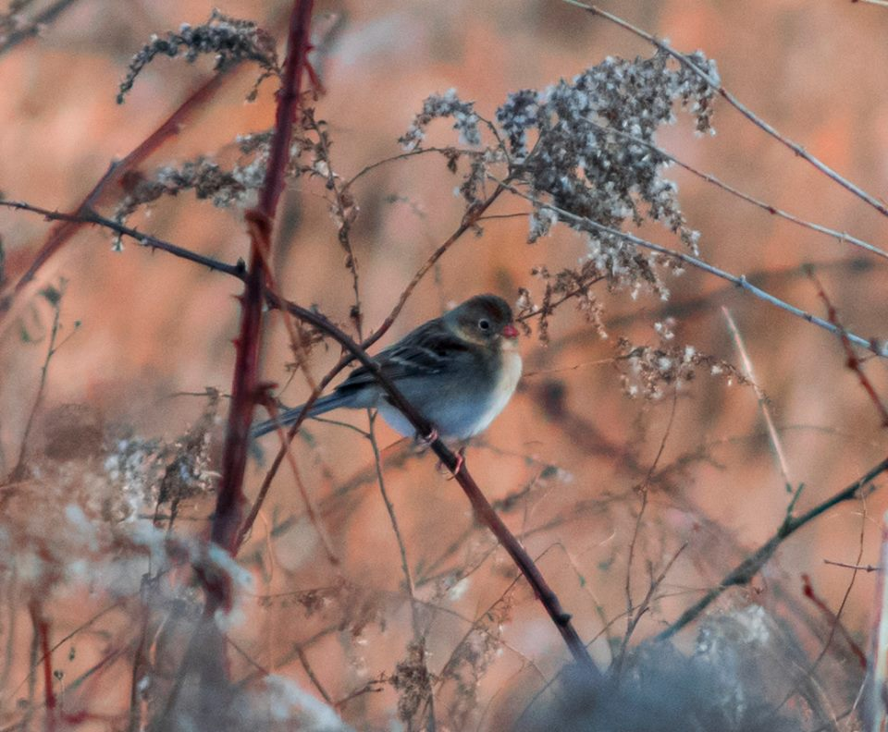

Field Sparrow. This was one of 13 species that was seen by only one birding party. Photo by Michael McGuire.

Raptors, raptors, raptors!

Raptors were everywhere. We had 11 species of diurnal birds of prey plus both vulture species. Topping the list was an Osprey found by David Hafer and Than Mitchell along the Susquehanna River, only the second time one has been found on the Lewisburg Christmas Count. Additionally, Roy Fontaine located two Rough-legged Hawks, a species that is missed more often than found in recent years. A Peregrine and a Merlin also made an appearance to go along with their smaller kestrel cousin. [We’re still including the falcons here, even though it is now known they are more closely related to parrots and passerines than to the hawks and eagles.] Cooper’s Hawks and Northern Harriers were in good numbers as well.

The whole is less than the sum of parts. For the first time I have reduced the Bald Eagle total by discounting the five that Joanne and I saw. I’m confident they were part of the nine (!) that Judy & Jack & Jill had in their adjacent territory. Even with the subtraction, sixteen eagles is again an all-time high. Every year we seem to see a few more. Red-tailed Hawks also set a high record with 124; that’s considerably more than one per square mile of count circle territory.

Pileated Woodpeckers had a good showing with 19, and several folks remarked that the number of Blue Jays was fairly high. It was.

It was cold, seven degrees in the predawn, and the water was frozen on most of the small streams and creeks. Not surprisingly, waterfowl numbers were low, and no one reported a snipe for the first time in 30 years. Ouch!

The well publicized Wolfe Land Red-headed Woodpeckers could not be located in spite of being seen on Monday. Nevertheless, others came through, and our total of 5 was bested only by the 7 that were found in 1994.

We had 65 species altogether, up one from last year. A comparison with 2015 shows that Turkey Vulture, Osprey, Red-shouldered Hawk, Merlin, Peregrine, Red-breasted Nuthatch, Hermit Thrush, and Purple Finch were birds that appeared this year, but not last.

Birds that we found last year, but not this year included Hooded Merganser, Ring-necked Pheasant, Golden Eagle, Killdeer, Wilson’s Snipe, Savannah Sparrow, and Swamp Sparrow.

In spite of postponing our scheduled Saturday count to a weekday we still had 41 birders, and all territories were convered. The gang included: Warren Abrahamson, Steve Anderson, Brent Bacon, Kay Cramer, Ken Eisenstein, Betsy Fickes, Roy Fontaine, Geoff Goodenow, Bob Gutheinz, David Hafer, Rolf & Annick Helbig, Galen & Bonnie Ingram, Jill Largent, Jim & Diane Lengle, Bill Malone, Jen Mattive, Jack McCann, Wayne McDiffett, Larry McGraw, Michael McGuire, Rebecca Meyers, Than Mitchell, Mike Molesevich, Judy Peeler, Thom Rippon, Allen & Joanne Schweinsberg, Ralph & Lauri Shaffer, Bill & Ellen Snyder, Joe Southerton, Mark Spiro, Logan Stenger, Lynn Tanner, John Tonzetich, Don Ulrich, Tom Yannaccone.

Please save Saturday, December 16, for the 2017 Christmas Bird Count

The results:

Canada Goose 165
Wood Duck 2
American Black Duck 4
Mallard 267
Common Merganser 21
Wild Turkey 47
Great Blue Heron 5
Black Vulture 30
Turkey Vulture 2
Osprey 1
Bald Eagle 16
Northern Harrier 9
Sharp-shinned Hawk 1
Cooper’s Hawk 12
Red-shouldered Hawk 2
Red-tailed Hawk 124
Rough-legged Hawk 2
Ring-billed Gull 11
Herring Gull 1
Rock Pigeon 898
Mourning Dove 253
Screech Owl 9
Great Horned Owl 4
Belted Kingfisher 10
Red-headed Woodpecker 5
Red-bellied Woodpecker 76 Yellow-bellied Sapsucker 1
Downy Woodpecker 100
Hairy Woodpecker 17
Northern Flicker 14
Pileated Woodpecker 19 American Kestrel 27
Merlin 1
Peregrine 1
Blue Jay 247
American Crow 484
Common Raven 13
Horned Lark 164
Black-capped Chickadee 207
Tufted Titmouse 174
Red-breasted Nuthatch 6
Wte-breasted Nuthatch 121

Brown Creeper 7
Golden-crowned Kinglet 13
Ruby-crowned Kinglet 1
Carolina Wren 45
Winter Wren 2
Eastern Bluebird 192
Hermit Thrush 1
American Robin 16
Northern Mockingbird 59
European Starling 3655
Cedar Waxwing 11
American Tree Sparrow 91
Field Sparrow 1
Song Sparrow 47
White-throated Sparrow 227
White-crowned Sparrow 15
Dark-eyed Junco 647
Northern Cardinal 136
Purple Finch 2
House Finch 188
Pine Siskin 11
American Goldfinch 100
House Sparrow 532

