The 2017
Lewisburg
Christmas Bird Count

We dedicated the 2014 Christmas Bird Count to the memory of Dick Nickelsen, a wonderful friend who was the compiler of this bird count for approximately twenty years. Back then I could not locate this photo of “Nick,” but it has resurfaced, and I cannt resist including it now.

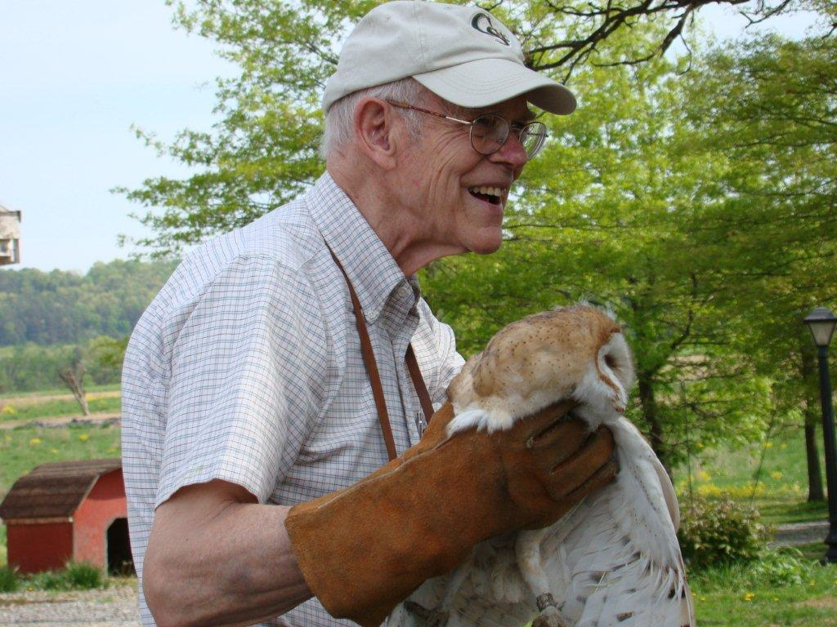

Highs and Lows

Let’s begin with Bald Eagles. We had 25 reported by 10 different parties. Could there have been some duplication? Sure. These birds are big and easy to spot. But 25 easily beats last year’s 16. When will this trend stop?
Ravens too. Thirty-six easily bested the recent record of 20. Like the eagle, this species seems to have lost much of its waryness. They are no longer confined to wilderness.
It’s yet another high for Red-bellied Woodpecker, and for the first time we had more of these than Downy Woodpeckers. Wow!
Towhee appeared for the first time in twenty years, and three of them gave us another all-time high.
Finally, 19 Screech Owls tied a record. There are lots out there, and Screech Owl totals in a given year probably just reflect pre-dawn effort.

Lows were more significant than highs. What happened to the familiar “winter woodlands gang”? Chickadee – lowest since 1972. Titmouse – lowest since 1972. Brown Creeper – one Brown Creeper. ONE! Junco – lowest since 1971. Cardinal – lowest since 1973. Goldfinch – lowest since 1970. The previous lows occurred when the Lewisburg count had very few participants before the formation of Seven Mountains Audubon. It’s true that our effort this year, measured in “party hours,” was a little lower, but that does not begin to explain this severe decline of generally common winter birds.
I’m saving American Crow for last. Our total, 264, was easily lowest ever. That includes every count back to 1949, when Hollis Ross initiated the Lewisburg Christmas Count all by himself. Even he, alone, had more than 264. It was only as recently as 1999 wnen we were counting crows in the tens of thousands and had a huge roost on Milton Island just outside the perimiter of our count circle. West Nile Virus seems to be the cause of this decline.

We had 63 species altogether, down two from last year. A comparison with 2016 shows that Green-winged Teal, Ring-necked Pheasant, Ruffed Grouse, Wilson’s Snipe. Savannah Sparrow, Swamp Sparrow, Eastern Towhee, and Lapland Longspur were birds that appeared this year, but not last.
Birds that we found last year, but not this year, included Wood Duck, Wild Turkey, Osprey, Red-shouldered Hawk, Herring Gull, Merlin, Peregrine, Ruby-crowned Kinglet, Cedar Waxwing, and Pine Siskin.

The gang of observers included: Warren Abrahamson, Brent Bacon, Mark & Sarah Berryman, Joanne Cooper, Kay Cramer, Betsy Fickes, Roy Fontaine, Kerry Givens, Geoff Goodenow, Bob Gutheinz, David Hafer, Rolf Helbig, Galen & Bonnie & Hannah Ingram, Jill Largent, Jim & Diane Lengle, Bill Malone, Barbara Martin, Jack McCann, Wayne McDiffett, Larry McGraw, Than and Margaret Mitchell, Mike Molesevich, Marilyn Murphy, Thi Nguyen, Judy Peeler, Thom Rippon, Allen & Joanne Schweinsberg, Ralph & Lauri Shaffer, Joe Southerton, Steve Stanko, Logan Stenger, Lynn Tanner, Don Ulrich, Tom Yannaccone.
Please save Saturday, December 15, for the 2018 Christmas Bird Count

The results:

Canada Goose 463

American Black Duck 9
Mallard 184
Green-winged Teal 1
Common Merganser 31
Ring-necked Pheasant 2
Ruffed Grouse 1
Great Blue Heron 11
Black Vulture 1
Turkey Vulture 3
Bald Eagle 25
Northern Harrier 4
Sharp-shinned Hawk 3
Cooper’s Hawk 5
Accipiter sp. 2
Red-tailed Hawk 56
Rough-legged Hawk 1
Wilson’s Snipe 4
Ring-billed Gull 42
Rock Pigeon 706
Mourning Dove 347
Screech Owl 19
Great Horned Owl 6
Belted Kingfisher 10
Red-headed Woodpecker 3
Red-bellied Woodpecker 94 Yellow-bellied Sapsucker 3
Downy Woodpecker 67
Hairy Woodpecker 8
Northern Flicker 8
Pileated Woodpecker 8
American Kestrel 50
Blue Jay 167
American Crow 264
Common Raven 36
Horned Lark 435
Black-capped Chickadee 61
Tufted Titmouse 74
Red-breasted Nuthatch 2
Wte-breasted Nuthatch 75
Brown Creeper 1
Golden-crowned Kinglet 24
Carolina Wren 48
Winter Wren 2
Eastern Bluebird 92
Hermit Thrush 3
American Robin 12
Northern Mockingbird 41
European Starling 3676
American Tree Sparrow 35
Field Sparrow 14
Savannah Sparrow 2
Song Sparrow 53
Swamp Sparrow 1
White-throated Sparrow 218
White-crowned Sparrow 23
Dark-eyed Junco 370
Eastern Towhee 3
Lapland Longspur 1
Northern Cardinal 120
Purple Finch 1
House Finch 176
American Goldfinch 30
House Sparrow 442

