The 2020
Lewisburg
Christmas Bird Count

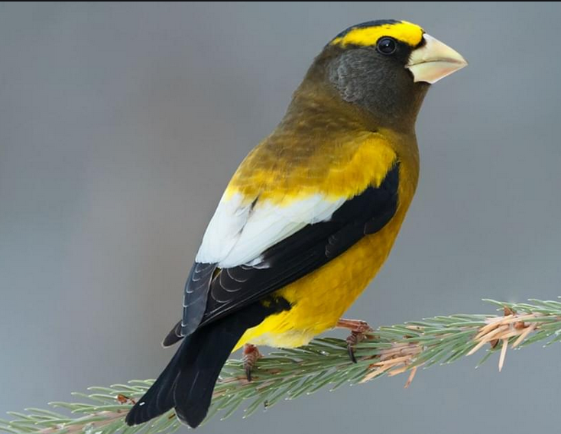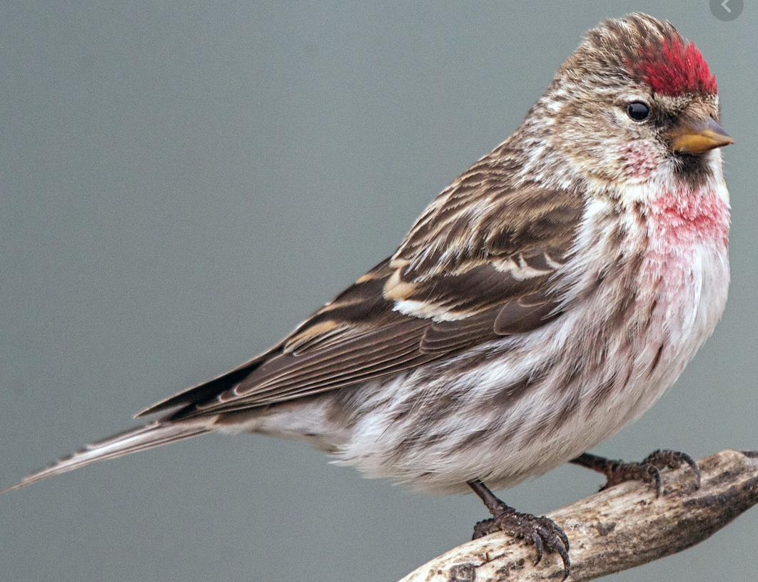

We had our first Evening Grosbeak since 1999! Thank you, David Hafer. It’s hard to believe, but in the twenty-year interval from 1968 through 1987 we averaged over 240 Evening Grosbeaks per year with a high count of 1628 in 1978. They were more common than House Sparrows that year. It’s not completely understood why grosbeaks exploded, then declined sharply, in the 20th century.

We had our 2nd occurrence of Common Redpoll in 25 years! Thank you, Michael McGuire. The redpolls had been hanging out with Pine Siskins near the East Buffalo Township duck pond.

We observed 64 species altogether. A comparison with 2019, which was our best year in quite some time, shows that in addition to the grosbeak and redpolls we added Wilson’s Snipe, Yellow-rumped Warbler, Field Sparrow, Savannah Sparrow, Purple Finch, and Pine Siskin.

Conversely, birds that we found last year, but not this year, were many. These included Mute Swan, Wood Duck, Gadwall, Bufflehead, Common Goldeneye, Ring-necked Pheasant, Ruffed Grouse, Wild Turkey, Herring Gull, Barred Owl, Red-headed Woodpecker, Merlin, Peregrine Falcon, and Fox Sparrow. Mike Molesevich did report a peregrine in 2020 – one day after the count .

Few species were found in large numbers. Steve Anderson spotted 15 Tundra Swans high overhead, an all-time record number. Bald Eagle at 22, Red-breasted Nuthatch at 37, and Common Raven at 31 were our second, second, and third highest tallies, respectively, since the Lewisburg count began in 1949.
Eagles are conspicuous and wide-ranging, so some of the 22 eagles may be duplicates. Also, two observers, not far apart, each reported exactly 5 Black Vultures, so it is reasonably safe to assume they were the same birds.

We had one each of six species, namely Hooded Merganser, Northern Harrier, Hermit Thrush, Yellow-rumped Warbler, Brown-headed Cowbird, and Evening Grosbeak. Also, American Crows, once found by the thousands, remain in severely depleted numbers.

We should mention one more species. Warren Abrahamson reported that his party had a coyote.

Finally, recall that we need to gather information for a report to National Audubon. Data like miles by car, miles by foot, hours by car, hours by foot. In 2020 we had a first. Thom Rippon submitted his miles and hours by tractor! It’s not what you are imagining. Thom’s new tractor has a heated cab.

Our 43 observers included: Warren Abrahamson, Steve Anderson, Kay Cramer, Tim Craries Sr., April Fairweather, Francesca Ferguson, Betsy Fickes, Roy Fontaine, Kerry Givens, Geoff Goodenow, Bob Gutheinz, David Hafer, Robert Hazard, Galen & Bonnie Ingram, Deepak Iyer, Kevin Klinger, Jill Largent, Alice Marquart, Barbara Martin, Jack McCann, Wayne McDiffett, Larry McGraw, Michael McGuire, Than & Margaret Mitchell, Mike Molesevich, Dianne Muchant, John & Judy Peeler, Thom Rippon, Kathy Rowe, Allen & Joanne Schweinsberg, Lauri Shaffer, Ellen Snyder, Emily Southerton, Joe Southerton, Logan & Tanna Stenger, Lynn Tanner, Bill Tyler, and Don Ulrich.
Sometimes we don’t notice the changing of the guard. Only 13 of the above folks were among the 38 participants in our count in 2006.
The Results

Canada Goose 368
Tundra Swan 15
American Black Duck 7
Mallard 247
Hooded Merganser 1
Common Merganser 66
Great Blue Heron 10
Black Vulture 5
Turkey Vulture 2
Bald Eagle 22
Northern Harrier 1
Sharp-shinned Hawk 2
Cooper’s Hawk 7
Accipiter sp 1
Red-tailed Hawk 61
Wilson’s Snipe 4
Ring-billed Gull 45
Rock Pigeon 688
Mourning Dove 227
Screech Owl 4
Great Horned Owl 2
Belted Kingfisher 11
Red-bellied Woodpecker 49
Yellow-bellied Sapsucker 3
Downy Woodpecker 67
Hairy Woodpecker 18
Northern Flicker 12
Pileated Woodpecker 9
American Kestrel 29
Blue Jay 82
American Crow 154
Common Raven 31
Horned Lark 140
Black-capped Chickadee 167
Tufted Titmouse 105
Red-breasted Nuthatch 37
White-breasted Nuthatch 74
Brown Creeper 11
Golden-crowned Kinglet 17
Ruby-crowned Kinglet 2
Carolina Wren 45
Winter Wren 2
Eastern Bluebird 128
Hermit Thrush 1
American Robin 31
Northern Mockingbird 38
European Starling 2114
Cedar Waxwing 26
Yellow-rumped Warbler 1
American Tree Sparrow 39
Field Sparrow 6
Savannah Sparrow 2
Song Sparrow 39
White-throated Sparrow 270
White-crowned Sparrow 6
Dark-eyed Junco 445
Northern Cardinal 148
Brown-headed Cowbird 1
Purple Finch 5
House Finch 165
Common Redpoll 3
Pine Siskin 83
American Goldfinch 140
Evening Grosbeak 1
House Sparrow 276

