The 2021
Lewisburg
Christmas Bird Count

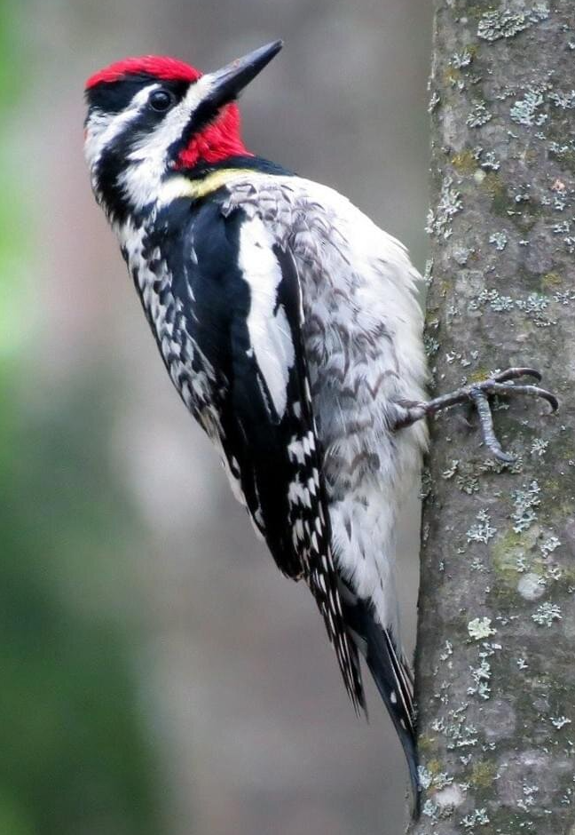
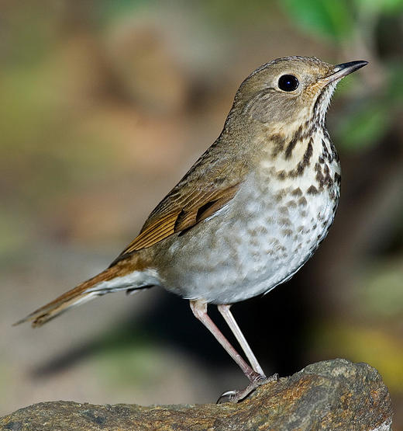

The weather was unpleasantly damp. Visibility was poor. Birds were silhouettes. We had fewer participants than usual, and folks who were out spent fewer hours than they might have otherwise. Nevertheless, our intrepid birders still tallied 64 species, matching last year’s total that was accomplished under much better circumstances.

We even achieved two new records. Hermit Thrush and Yellow-bellied Sapsucker, came in at seven individuals each -- both an all-time high. We also tallied 247 American Robins, the 2nd highest number ever.

Not surprisingly, there were lows. The 27 Red-tailed Hawks – that’s 27 wet, grumpy Red-tailed Hawks – were the lowest number in forty-eight years. Other common birds with low totals included Downy Woodpecker, American Crow, White-breasted Nuthatch, Eastern Bluebird, and Dark-eyed Junco.

A comparison with 2020 shows that we added Wood Duck, Ring-necked Pheasant, Wild Turkey, Peregrine Falcon, Killdeer, Red-headed Woodpecker, Swamp Sparrow, and Common Grackle. Conversely, birds that we found last year, but not this year, were Tundra Swan, Hooded Merganser, Black Vulture, Turkey Vulture, Purple Finch, Common Redpoll, Pine Siskin, and Evening Grosbeak.

There were twelve species that were recorded by a single party, namely Wood Duck, Black Duck, Sharp-shinned Hawk, Peregrine Falcon, Killdeer, Wilson’s Snipe, Red-headed Woodpecker, Common Raven, Winter Wren, Ruby-crowned Kinglet, Yellow-rumped Warbler, and Savannah Sparrow. We expect most of these to be elusive, but the lone Common Raven was a surprise. In recent years we have had over 30 of these.

Let’s look back. Here are the species totals since Seven Mountains Audubon first started managing these counts in 1974.

1974 - 1979 77 76 70 79 72 74
1980 - 1989 63 75 69 75 81 78 72 77 66 77
1990 - 1999 76 76 73 76 75 79 79 79 72 70
2000 - 2009 67 71 65 67 71 70 75 85 74 65
2010 - 2019 72 72 64 68 61 65 65 63 59 70
2020 - 2021 64 64

Do you spot the trend? We are averaging about ten fewer species than we once did. This is at least partly due to habitat degradation – residential development, big hog barns, big chicken barns, etc.

Let’s look forward. Many years have come and gone since 1974. We will now need a new compiler for the Lewisburg Christmas Bird Count in 2022. With an 80th birthday arriving in a few months, Allen is retiring. He is forever grateful for the many folks who contributed over the years, and these include the following …

Our 36 observers in 2021: Kay Cramer, Francesca Ferguson, Betsy Fickes, Roy Fontaine, Kerry Givens, Geoff Goodenow, Bob Gutheinz, David Hafer, Sabrina Kirby, Robert Hazard, Jill Largent, Jim & Diane Lengle, Bill Malone, Alice Marquart, Barbara Martin, Jack McCann, Larry McGraw, Michael McGuire, Mike Molesevich, Dianne Muchant, John & Judy Peeler, Bob Reyda, Steve Stanko, Thom Rippon, Allen & Joanne Schweinsberg, Deb Slade, Ellen Snyder, Emily Southerton, Joe Southerton, Logan Stenger, Lynn Tanner, Bill Tyler, and Don Ulrich.

The Results

Canada Goose 338
Wood Duck 1
American Black Duck 1
Mallard 162
Common Merganser 7
Ring-necked Pheasant 2
Wild Turkey 70
Great Blue Heron 11
Bald Eagle 5
Northern Harrier 3
Sharp-shinned Hawk 1
Cooper’s Hawk 9
Red-tailed Hawk 27
Killdeer 1
Wilson’s Snipe 1
Ring-billed Gull 2
Rock Pigeon 786
Mourning Dove 169
Screech Owl 14
Great Horned Owl 4
Belted Kingfisher 10
Red-headed Woodpecker 1
Red-bellied Woodpecker 70
Yellow-bellied Sapsucker 7
Downy Woodpecker 62
Hairy Woodpecker 14
Northern Flicker 19
Pileated Woodpecker 12
American Kestrel 27
Peregrine Falcon 1
Blue Jay 140
American Crow 124
Common Raven 1
Horned Lark 23
Black-capped Chickadee 66
Tufted Titmouse 59
Red-breasted Nuthatch 5
White-breasted Nuthatch 55
Brown Creeper 6
Golden-crowned Kinglet 27
Ruby-crowned Kinglet 1
Carolina Wren 34
Winter Wren 1
Eastern Bluebird 59
Hermit Thrush 7
American Robin 247
Northern Mockingbird 22
European Starling 2034
Cedar Waxwing 106
Yellow-rumped Warbler 2
American Tree Sparrow 41
Field Sparrow 7
Savannah Sparrow 2
Song Sparrow 77
Swamp Sparrow 4
White-throated Sparrow 323
White-crowned Sparrow 10
Dark-eyed Junco 211
Northern Cardinal 100
Common Grackle 5
Brown-headed Cowbird 251
House Finch 66
American Goldfinch 19
House Sparrow 100

